# CS 255 System Design Document Nick Burnette

## UML Diagrams

### UML Use Case Diagram

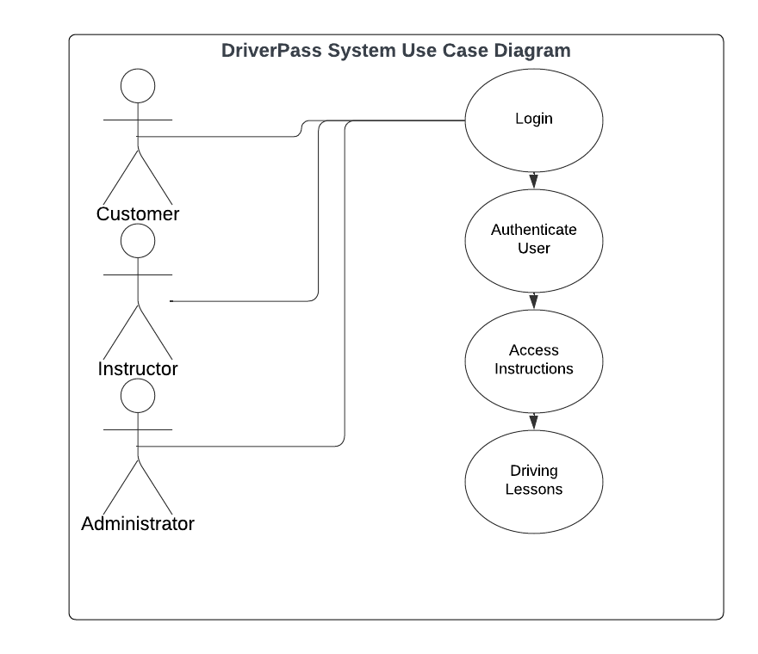

### UML Activity Diagrams

Use Case Diagram: Instruction

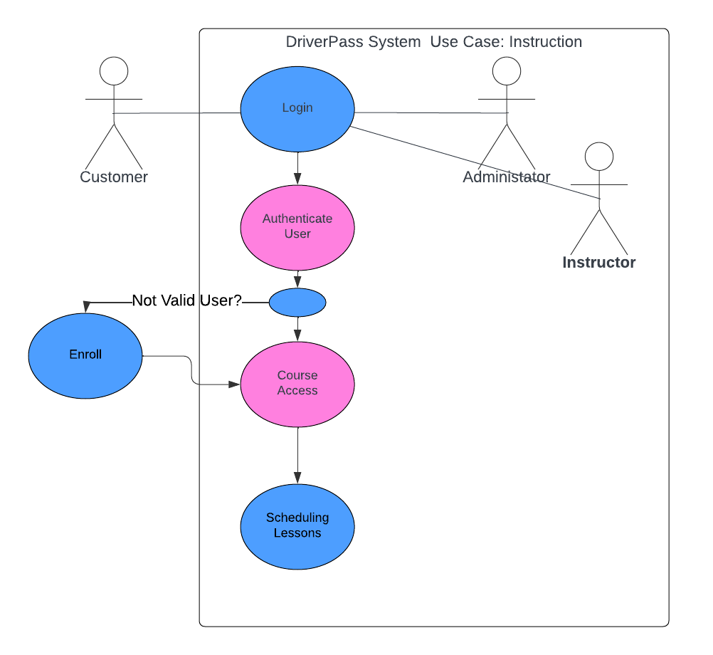

Use Case Diagram: DMV

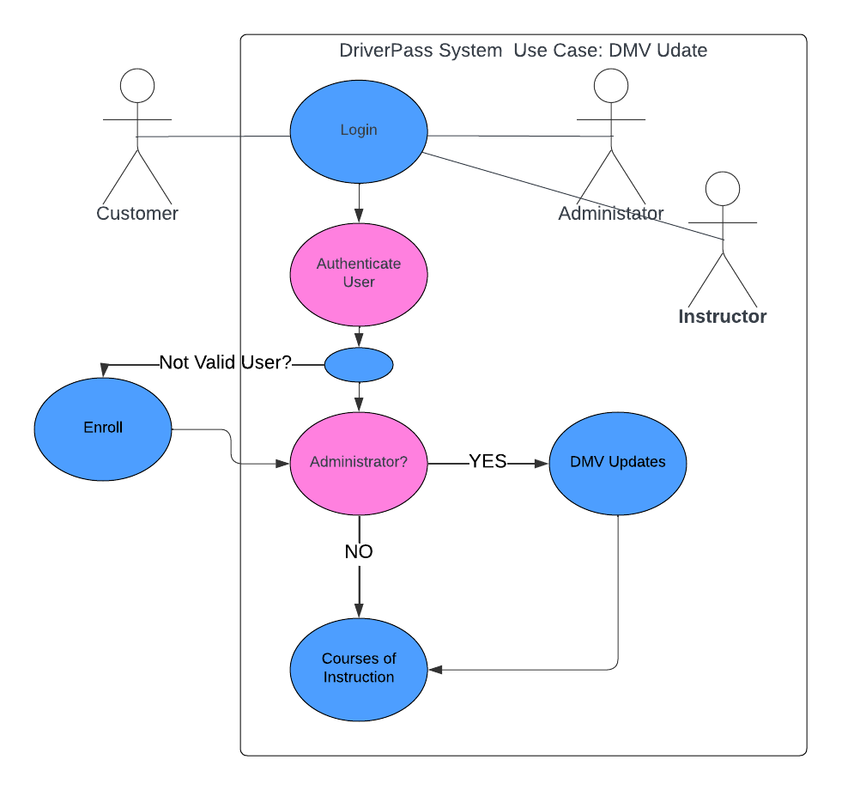

### UML Sequence Diagram

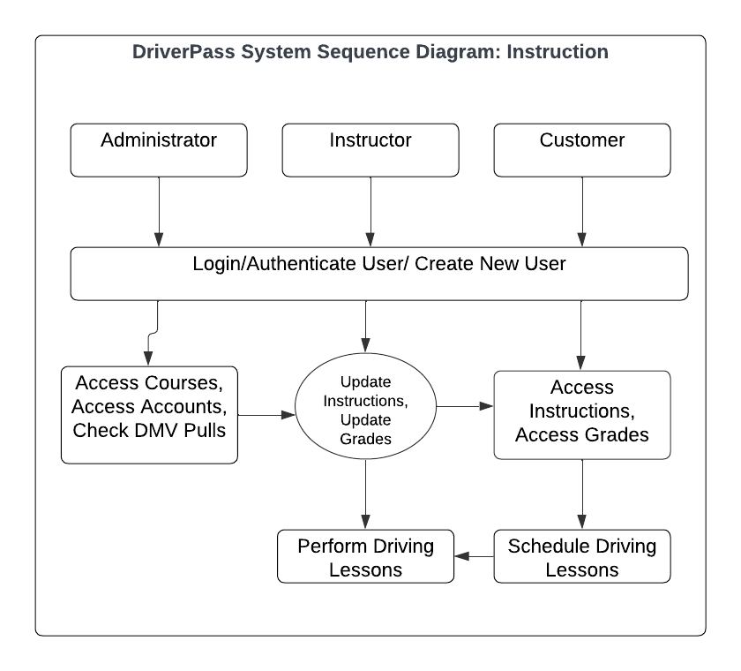

### UML Class Diagram

## Technical Requirements

Here are the technical requirements and infrastructure necessary for this DriverPass System:

Hardware:

* Servers able to host web-based applications
* Devices with local storage for offline operations
* Network infrastructure to support high-volume traffic

Software:

* Web server software (Apache, Nginx, eg.) to host the application
* Database management system (Amazon RDS or Google Cloud SQL) for storing user data securely
* Cloud-based storage service (Amazon S3 or Google Cloud Storage) for storing instructional multimedia content
* Security Services (AWS Security or Google Cloud Security Command Center) for secure data handling and logging
* Monitoring Services (Amazon CloudWatch or Google Cloud Monitoring) for system health and performance monitoring

***Note: all of the software services could be performed in house but the cost would not be better and the results questionable. Outsourcing allows for focus on the System goals while ensuring scalability.

Infrastructure:

* Cloud-based infrastructure (AWS or Google Cloud) allows for scalability and accessibility
* High-speed internet connectivity required for fast response times
* Load balancing mechanisms to handle high volumes of simultaneous users
* Data backup and disaster recovery methods to ensure data integrity and availability